Cryptography Laboratory Experiments (Continuation)

Experiment No: 7
Experiment Name: DES
Aim: To implement the Data Encryption Standard (DES) algorithm using Python.
Algorithm:
- Read the plaintext.
- Read an 8-byte key.
- Encrypt using DES.
- Decrypt using the same key.
- Display the results.
Code:
from Crypto.Cipher import DES
from Crypto.Util.Padding import pad, unpad
key=input("Enter 8-character key: ").encode()
plaintext=input("Enter the plain text: ")
cipher=DES.new(key, DES.MODE_ECB)
encrypted=cipher.encrypt(pad(plaintext.encode(), DES.block_size))
print(encrypted.hex())
print(unpad(cipher.decrypt(encrypted),DES.block_size).decode())
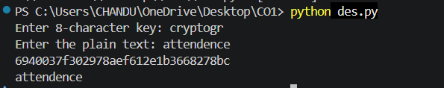

Experiment No: 8
Experiment Name: 2DES (Double DES)
Aim: To implement Double DES encryption and decryption using Python.

Algorithm:
1. Read the plaintext.
2. Read two 8-byte keys.
3. Encrypt using Key1 then Key2.
4. Decrypt using Key2 then Key1.
5. Display the results.

Code:
from Crypto.Cipher import DES
from Crypto.Util.Padding import pad, unpad
k1=input("Enter Key1 (8 chars): ").encode()
k2=input("Enter Key2 (8 chars): ").encode()
pt=input("Enter Plaintext: ").encode()
c1=DES.new(k1,DES.MODE_ECB)
c2=DES.new(k2,DES.MODE_ECB)
enc=c2.encrypt(c1.encrypt(pad(pt,8)))
print("Encrypted:",enc.hex())
d2=DES.new(k2,DES.MODE_ECB)
d1=DES.new(k1,DES.MODE_ECB)
dec=unpad(d1.decrypt(d2.decrypt(enc)),8)
print("Decrypted:",dec.decode())

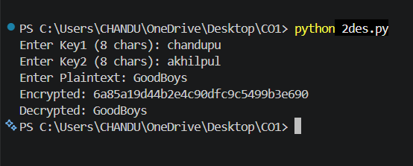Experiment No: 9
Experiment Name: 3DES (Triple DES)
Aim: To implement Triple DES encryption and decryption using Python.

Algorithm:
1. Read the plaintext.
2. Read a 16/24-byte key.
3. Encrypt using Triple DES.
4. Decrypt using the same key.
5. Display the results.

Code:
from Crypto.Cipher import DES3
from Crypto.Util.Padding import pad,unpad
key=DES3.adjust_key_parity(b"Sixteen byte key")
cipher=DES3.new(key,DES3.MODE_ECB)
pt=input("Enter Plaintext: ").encode()
enc=cipher.encrypt(pad(pt,8))
print(enc.hex())
print(unpad(cipher.decrypt(enc),8).decode())

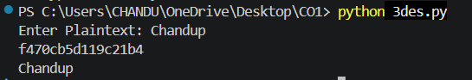Experiment No: 10
Experiment Name: Modes of DES
Aim: To implement DES in ECB, CBC, CFB, OFB and CTR modes.

Algorithm:
1. Read the plaintext.
2. Select DES mode.
3. Encrypt the plaintext.
4. Decrypt the ciphertext.
5. Display the results.

Code:
# Replace DES.MODE_ECB with DES.MODE_CBC, DES.MODE_CFB,
# DES.MODE_OFB or DES.MODE_CTR as required.
from Crypto.Cipher import DES
print("Supported Modes: ECB, CBC, CFB, OFB, CTR")

Experiment No: 11
Experiment Name: RSA
Aim: To implement RSA encryption and decryption using Python.

Algorithm:
1. Generate RSA keys.
2. Read plaintext.
3. Encrypt using public key.
4. Decrypt using private key.
5. Display the results.

Code:
from Crypto.PublicKey import RSA
from Crypto.Cipher import PKCS1_OAEP
key=RSA.generate(2048)
pub=PKCS1_OAEP.new(key.publickey())
pri=PKCS1_OAEP.new(key)
msg=input("Enter Plaintext: ").encode()
enc=pub.encrypt(msg)
print(enc.hex())
print(pri.decrypt(enc).decode())
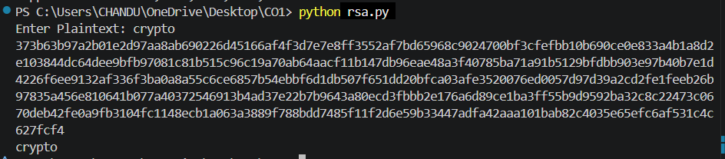

Experiment No: 12
Experiment Name: Diffie-Hellman
Aim: To implement Diffie-Hellman key exchange using Python.

Algorithm:
1. Choose prime and generator.
2. Generate private keys.
3. Generate public keys.
4. Exchange and compute shared secret.
5. Display the shared key.

Code:
p=23; g=5
a=6; b=15
A=pow(g,a,p)
B=pow(g,b,p)
ka=pow(B,a,p)
kb=pow(A,b,p)
print("Shared Key:",ka,kb)

Experiment No: 13
Experiment Name: Elliptic Curve Cryptography (ECC)
Aim: To implement ECC key generation using Python.

Algorithm:
1. Generate ECC key pair.
2. Read plaintext.
3. Encrypt using ECC-based method.
4. Decrypt using private key.
5. Display the results.

Code:
from Crypto.PublicKey import ECC
key=ECC.generate(curve="P-256")
print(key.export_key(format="PEM"))
print(key.public_key().export_key(format="PEM"))

